CSD-4464 Programming Java EE

WEEK 8

Assignment 4

Date: 18th March 2022

Output

Group E Members:

Anirudh Vallampatla C0796429

Meghana Kondaveeti C0784302

Srikanth Ajith Kumar Yarram C0793406

Vishal Kumar C0793379

Yamini Rathod C0796390

Folder Structure

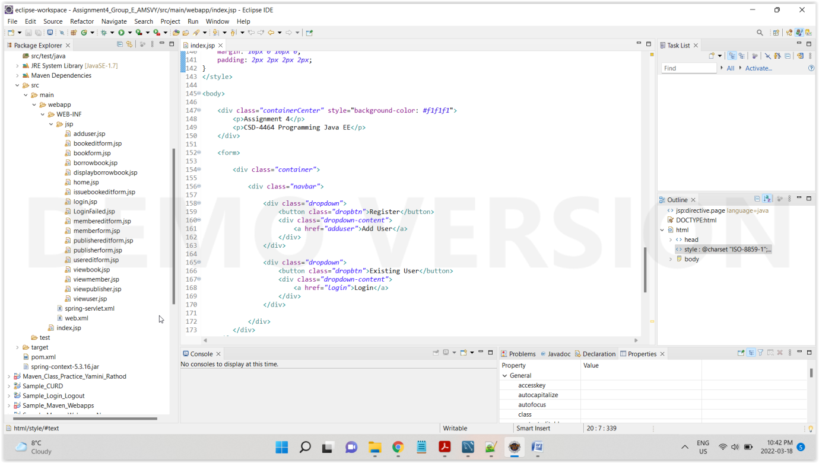

Execution

Main Index Page

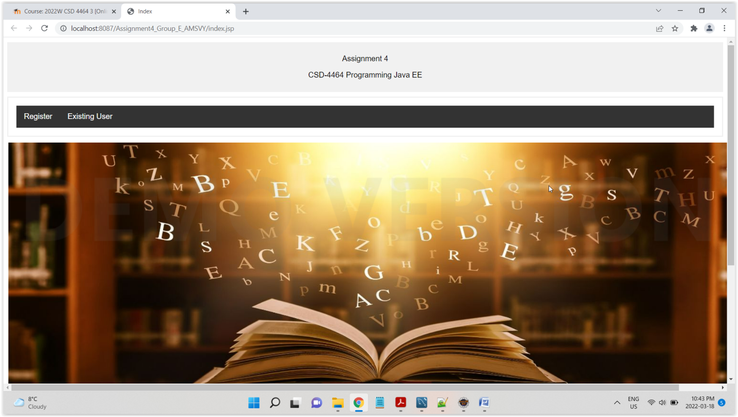

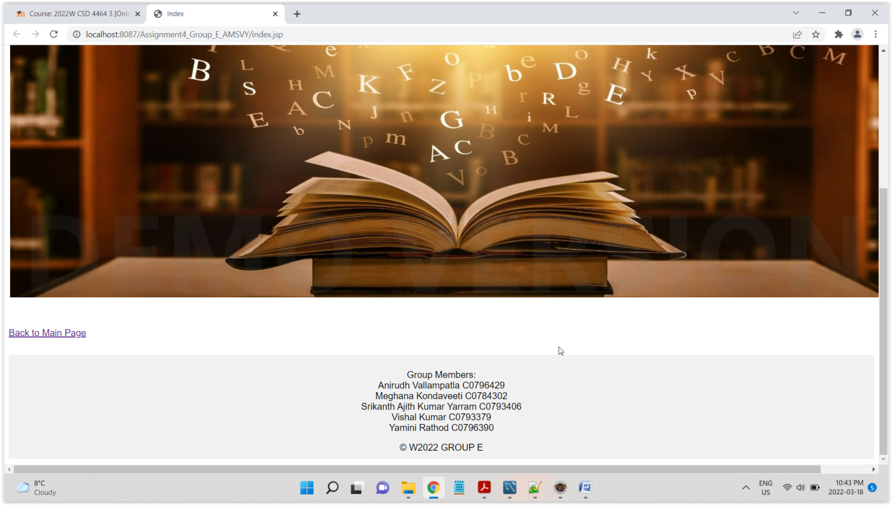

Register New User

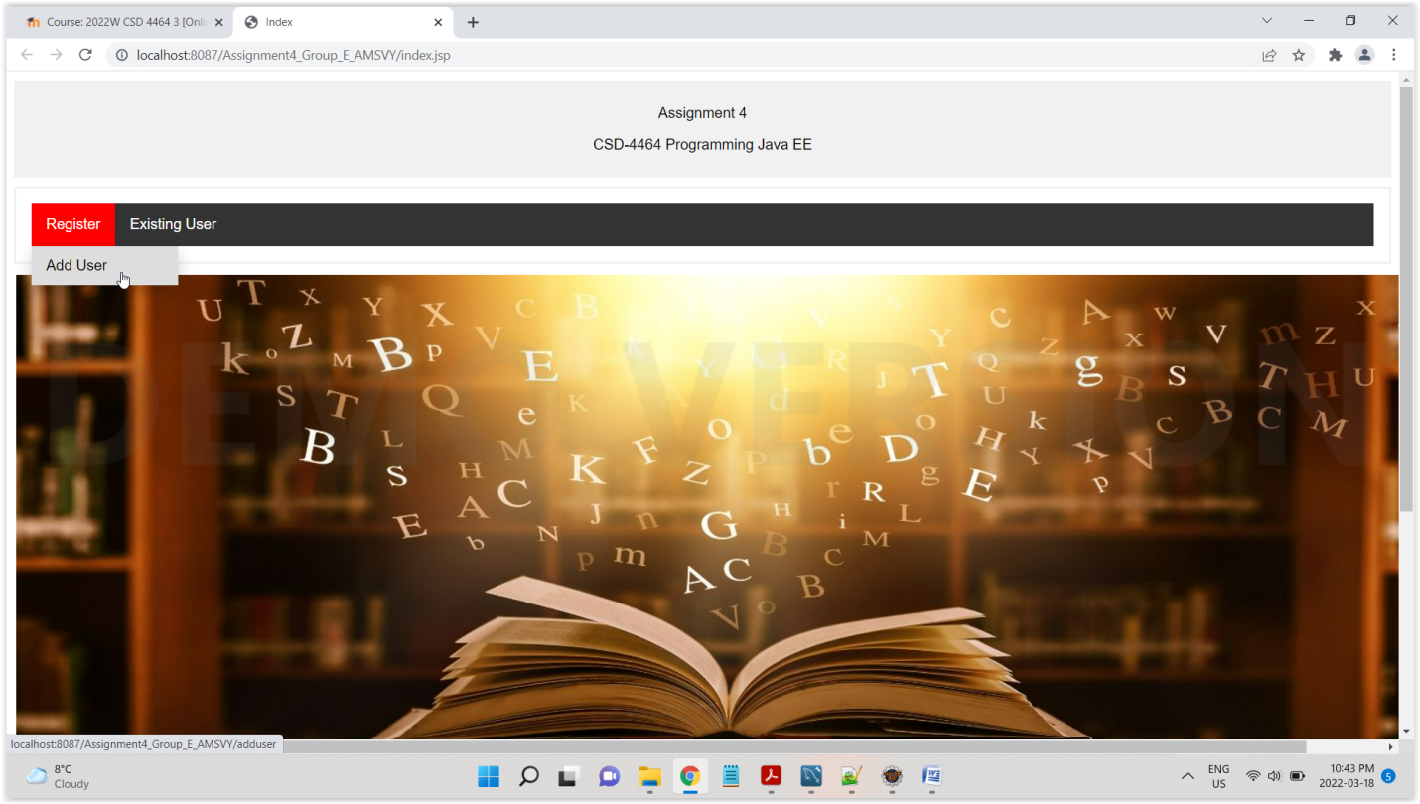

Validation

